Hack BI V JAVA

horizontal line

**1. About**

* This workshop will introduce Java to beginners who have never programmed Java.
* Java is a programming language and computing platform where you can develop applications. It is object-oriented like C++ but with advanced and simplified features.

**2. Getting Started**

* To get started, download JGRASP by clicking on this link and clicking download depending on whether you have Mac OS, Windows or Linux.
* <https://spider.eng.auburn.edu/user-cgi/grasp/grasp.pl?;dl=download_jgrasp.html>
* 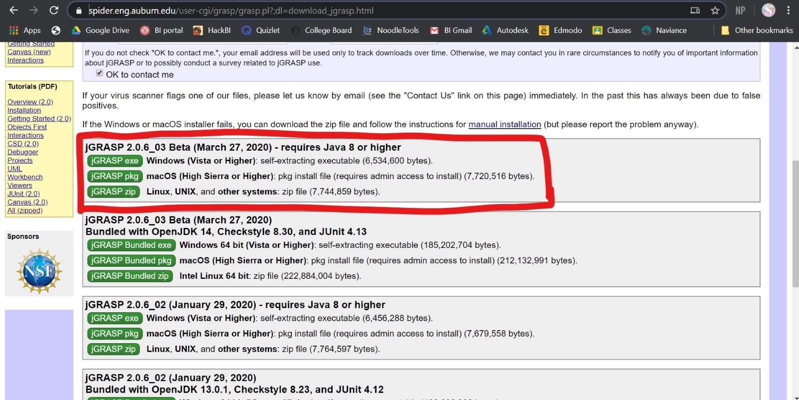
* Then follow the setup wizard and finish installation

**3. Coding**

* Create a HelloWorld class going over the basics
* Beginner Java Project

**4. More Resources**

* Java 7 API
* <https://docs.oracle.com/javase/7/docs/api/>
* Codecademy
* <https://www.codecademy.com/learn/learn-java>